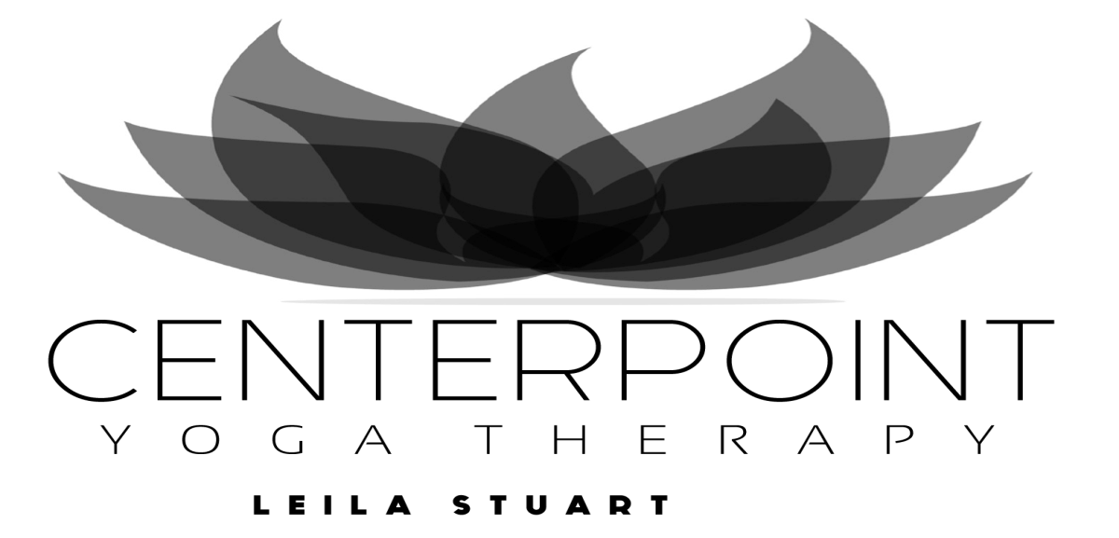

Breathe Calmly. Move with Ease. Heal Yourself.
April 7 -June 18, 2026 (11 classes CDN $286)
Tuesdays | 10:00am - 12:00pm | Therapeutic Yoga with Leila in studio
Wednesdays | 10:00am - 12:00pm | Therapeutic Yoga with Janine online
Thursdays | 10:00am - 12:00pm | Therapeutic Yoga with Leila online
Thursdays | 6:30 pm - 8:30 pm | Therapeutic Yoga with Leila online
Therapeutic Yoga
Research proves that yoga therapy benefits a wide variety of medical conditions, including chronic pain, stiffness/inflexibility, back pain, headaches, fibromyalgia, anxiety, depression, cancer, and arthritis.
Learn to heal yourself with gentle movement, breath, and meditation. Practice techniques to re-pattern dysfunctional alignment, breath, and mind habits. Relax your body and calm your mind and emotions.

Leila Stuart, BA, LLB, RMT (retired), has 30 + years experience as a Massage Therapist, Yoga Therapist and teacher. She integrates diverse movement therapies, yoga practices and mindfulness techniques into a unique and highly effective method of yoga therapy that can improve all aspects of health and well-being. She has authored two books and teaches internationally. | Janine Naman is an experienced yoga teacher, massage practitioner, healer, and graduate of Leila's yoga therapy training. She is committed to making yoga accessible to everyone.

A non-refundable deposit of $50 is included in the full fee amount). Payment may be made by e-transfer (or PayPal for international students) to ls@leilastuart.com or by cheque made out to Centerpoint Yoga Therapy Studio, mailed to the address below. Register early as classes fill quickly!
Name |  | Centerpoint Yoga Therapy  15600 Cliff Avenue, White Rock, BC V4B 1V9  Tel: 604-536-7894  Email: ls@leilastuart.com  www.leilastuart.com
Address
Phone
Email
Day/time
Payment

