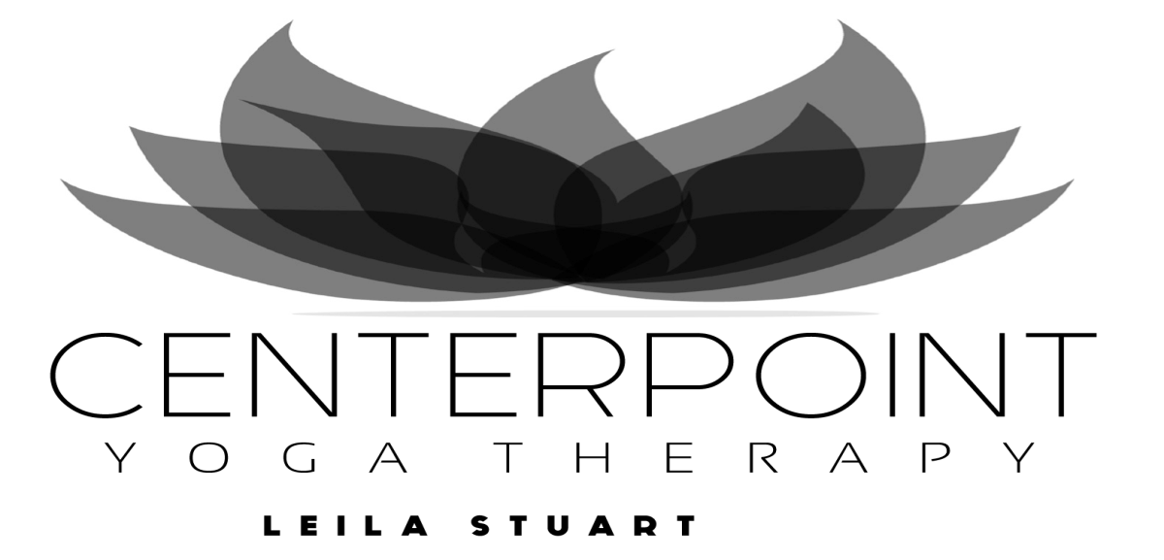

Breathe Calmly. Move with Ease. Heal Yourself.
January 14-June 18, 2026 (11 classes CDN $286)
Wednesdays | 10:00am - 12:00pm | Introductory Therapeutic Yoga with Janine online
Thursdays | 10:00am - 12:00pm | Introductory Therapeutic Yoga with Janine online
Thursdays | 6:30 pm - 8:30 pm | Ongoing Therapeutic Yoga with Janine online
Therapeutic Yoga
Research proves that yoga therapy benefits a wide variety of medical conditions, including chronic pain, stiffness/inflexibility, back pain, headaches, fibromyalgia, anxiety, depression, cancer, and arthritis.
Learn to heal yourself with gentle movement, breath, and meditation. Practice techniques to re-pattern dysfunctional alignment, breath, and mind habits. Relax your body and calm your mind and emotions.
Ongoing classes are for those with some yoga experience who want to achieve more profound results, or for beginners after consulting with Leila.
Leila Stuart, BA, LLB, RMT (retired), has 30 + years’ experience  as a Massage Therapist, Yoga Therapist and teacher. She integrates diverse movement therapies, yoga practices and mindfulness techniques into a unique and highly effective method of yoga therapy that can improve all aspects of health and well-being. She has authored two books and teaches internationally. | Janine Naman is an experienced yoga teacher, massage practitioner, healer, and graduate of Leila's yoga therapy training. She is committed to making yoga accessible to everyone.

A non-refundable deposit of $50 is included in the full fee amount). Payment may be made by e-transfer (or PayPal or Wise for international students) to ls@leilastuart.com or by cheque made out to Centerpoint Yoga Therapy Studio, mailed to the address below. Register early as classes fill quickly!
Name |  | Centerpoint Yoga Therapy  15600 Cliff Avenue, White Rock, BC V4B 1V9  Tel: 604-536-7894  Email: ls@leilastuart.com  www.leilastuart.com
Address
Phone
Email
Day/time
Payment

